**Project Design Phase-II**

**Data Flow Diagram & User Stories**

|  |  |
| --- | --- |
| Date | 03 November 2022 |
| Team ID | PNT2022TMID12521  **Explore AS, differentiate** |
| Project Name | Project – Developing a flight delay prediction model by using machine learning |
| Maximum Marks | 4 Marks |

**Data Flow Diagrams:**

A Data Flow Diagram (DFD) is a traditional visual representation of the information flows within a system. A neat and clear DFD can depict the right amount of the system requirement graphically. It shows how data enters and leaves the system, what changes the information, and where data is stored.

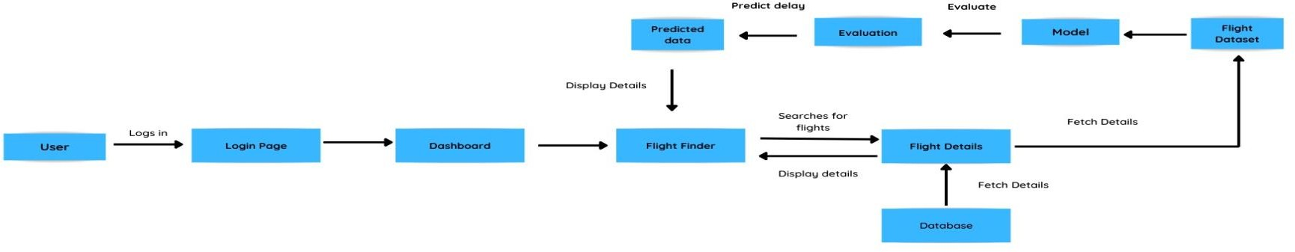

**User Stories**

Use the below template to list all the user stories for the product.

| **User Type** | **Functional Requirement (Epic)** | **User Story Number** | **User Story / Task** | **Acceptance criteria** | **Priority** | **Release** |
| --- | --- | --- | --- | --- | --- | --- |
| Customer (Web user) | Registration | USN-1 | As a user, I can register for the application by entering my email, password, and confirming my password. | I can access my account / dashboard | High | Sprint-1 |
|  |  | USN-2 | As a user, I will receive confirmation email once I have registered for the application | I can receive confirmation email & click confirm | High | Sprint-1 |
|  |  | USN-3 | As a user, I can register for the  application through Facebook | I can register & access the dashboard with Facebook Login | Low | Sprint-2 |
|  | Login | USN-5 | As a user, I can log into the application by entering email & password | I can access the dashboard | High | Sprint-1 |
|  | Dashboard | USN-6 | As a user, I can navigate through different pages using the dashboard | I can access various pages | High | Sprint-1 |
|  | Search | USN-7 | As a user, I can search for flights for different locations | I can receive information on different flights for various locations. | High | Sprint-2 |
|  | View | USN-8 | As a user, I can view the details of flights. | I will get the information such as flight number, departure and arrival time. | High | Sprint-2 |
|  | Receive notifications | USN-9 | As a user, I will receive notifications about the flight. | I will get frequent updates of the flight’s location | Low | Sprint-3 |
|  | Track | USN-10 | As a user, I will track the location of my flight. | I can track my flight. | High | Sprint-3,4 |
| Administrator | GPS | USN-11 | As an admin, I will need the location of flights | I can track my flight. | High | Sprint-3,4 |
|  | Analyse | USN-12 | As an admin, I will analyse the given dataset | I can analyse the dataset | High | Sprint-2 |
|  | Predict | USN-13 | As an admin, I will predict the delays | I can predict the flight delays | High | Sprint-2 |